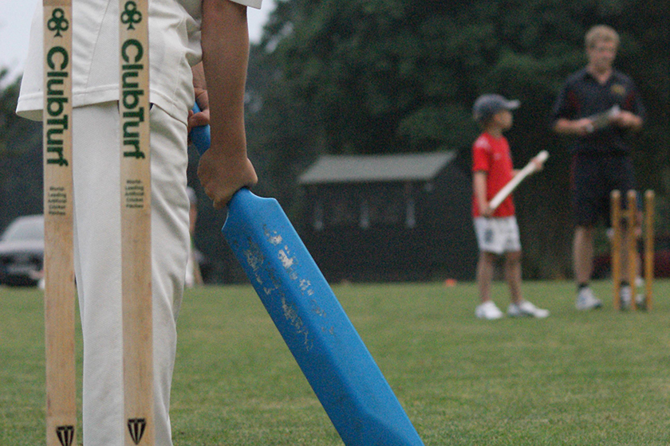

Coaching Days are £10 per child and then £5 for the second sibling. There are limited spaces so booking is essential! For more information and to book on please contact Lydia (07796344215)

**Monday 29th July 2019**

**Tuesday 6th August 2019**

**Monday 12th August 2019**

**All days 10am til 3pm**

**Summer Coaching Days**